MULTI-INTENT AI ASSISTANT
Stateful Conversational AI Agent Built on n8n + Ollama

Project Report
by: Aditya Patil
B.E. Computer Engineering | St. Francis Institute of Technology, Borivali
July 2026

🏗️ Stack  n8n + Docker + Ollama | 🤖 Model  llama3.1 (Local) | 💰 Cost  $0 (Fully Free) | 📡 API  Frankfurter (Free)

Table of Contents

1. Project Overview & What the Assistant Does
2. Technology Stack — Requirements & Why We Chose Them
3. Architecture — The State Machine Design
4. Workflow Diagram — Every Node Explained
5. Step-by-Step: How We Built This Project
6. Engineering Decisions & Changes Made During Build
7. Capabilities of the AI Assistant
8. Sample Conversation — Full End-to-End Flow
9. Evaluation Results — All 7 Required Evals
10. Limitations, Root Causes & How to Tackle Them
11. Conclusion

1. Project Overview — What the Assistant Does

The Multi-Intent AI Assistant is a stateful, conversational AI agent built entirely inside n8n — an open-source workflow automation platform. It simulates a professional phone-based support assistant that can handle multiple user requests within a single conversation, while maintaining full memory of the conversation state across every message.

Core Concept
Unlike a simple chatbot that responds to one message at a time and forgets everything, this assistant:
• Remembers who you are across every message in the conversation
• Knows exactly which stage of the conversation it is in
• Handles multiple requests in one session, one at a time, in order
• Allows users to add, remove or confirm their requests before processing
• Uses real live data — a free currency API and deterministic date calculations
• Runs 100% locally on your own machine — no cloud services, no API costs

What It Can Do
Capability | Description
Authentication | Verifies users by User ID and 4-digit PIN before any interaction. Locks out after 3 failed attempts.
Currency Conversion | Converts between 15+ currencies using live rates from Frankfurter API. Supports today, yesterday, specific dates, and even historical years.
Date & Time Queries | Resolves natural language date queries: 'coming Monday', 'tomorrow', '2 hours from now', 'next Friday', etc.
Intent Management | Captures multiple intents at once, allows confirmation and modification before processing.
Session Memory | Remembers the full conversation state across every message using a persistent Data Table.
Wrapup & Follow-up | After processing all requests, asks if the user needs anything else and can handle follow-up intents without re-authenticating.

2. Technology Stack — Requirements & Why We Chose Them

2.1 The Zero-Cost Constraint
The project was built under a strict constraint: absolutely no paid APIs, no cloud subscriptions, no trial credits. Every component needed to be free forever — not just for a limited trial period. This shaped every technology decision made in this project.

2.2 Technology Choices

Docker Desktop (Windows)
Aspect | Detail
What it is | A container runtime that runs software in isolated Linux environments on Windows.
Why we used it | n8n and Ollama are Linux-native applications. Docker lets them run on Windows without any compatibility issues.
Why not alternatives | Installing n8n directly on Windows is complex and error-prone. Docker makes it one command to start, one command to stop.
Cost | $0 — Docker Desktop is free for personal/educational use.
Requires | WSL2 (Windows Subsystem for Linux) — also free, enables the Linux kernel Docker needs.

n8n (Workflow Automation Platform)
Aspect | Detail
What it is | An open-source, self-hostable workflow automation tool with a visual canvas for connecting nodes.
Why we used it | The assignment specifically required building the workflow in n8n. It provides Chat Trigger, AI Agent, Data Table, HTTP Request, Switch, and Code nodes — everything needed.
Self-hosted benefit | Running n8n in Docker means it's free forever, unlike n8n Cloud which has a 14-day trial.
Version used | n8n latest (v1.x), accessed at http://localhost:5678
Cost | $0 — self-hosted, open-source.

Ollama + llama3.1 (Local LLM)
Aspect | Detail
What it is | Ollama is a local LLM runtime. llama3.1 is Meta's open-source 8B parameter language model.
Why we used it | The spec required GPT-4.1 (paid). Since no paid APIs were allowed, Ollama is the only way to run an LLM locally for free, forever.
How it connects to n8n | Ollama exposes an OpenAI-compatible API at port 11434. n8n's OpenAI Chat Model node is pointed at this endpoint instead of OpenAI's servers.
Model size | llama3.1 is 4.9 GB downloaded once. After that, all inference is local — no internet needed.
Tradeoff | llama3.1 is less reliable than GPT-4.1 at strict JSON output. This is addressed in the architecture.
Cost | $0 — open-source model, local inference.

Frankfurter API (Currency Rates)
Aspect | Detail
What it is | A free, open-source currency exchange rate API based on European Central Bank data.
Why we used it | Free with no API key required, no rate limits for reasonable use, supports historical rates back to 1999.
Endpoint used | https://api.frankfurter.dev/v1/{date}?from={FROM}&to={TO}
Supports | Latest rates, yesterday's rates, specific dates, historical years (nearest trading day).
Cost | $0 — completely free, no signup needed.

ngrok (Public URL Tunnel)
Aspect | Detail
What it is | A tunneling service that exposes your local server to the internet via a public HTTPS URL.
Why we used it | n8n runs on localhost. For submission, an external evaluator needs to access the chat — ngrok provides a public URL that forwards to localhost:5678.
Cost | $0 — free plan is sufficient for demo/evaluation purposes.
Limitation | URL changes every time ngrok restarts. Must keep ngrok running during evaluation.

3. Architecture — The State Machine Design

3.1 Why a State Machine?
The most important architectural insight in this project: n8n's Chat Trigger fires once per message and then stops. There is no persistent 'running' workflow waiting for the next message. Every message starts a fresh workflow execution from scratch.
This means the assistant cannot simply 'remember' where the conversation was by keeping variables in memory. After each message, everything in the execution context is gone. The solution: a state machine — a structured way of saving exactly where the conversation stands after every message, so the next execution can pick up precisely where the last one left off.

3.2 The State Object
Every conversation is represented by a single JSON state object stored in the n8n Data Table. Here is what it looks like:
{
"sessionId": "abc123", // unique ID per chat session
"stage": "AUTH", // current conversation stage
"authenticated": false, // has user logged in?
"userId": null, // verified user ID
"name": null, // verified user name
"failedAttempts": 0, // wrong PIN counter
"intents": "[]", // pending/done intents (JSON string)
"intentRetryCount": 0, // intent capture retry counter
"turnCount": 1, // total messages in session
"lastAgentResponse": "" // last thing the bot said
}

3.3 The 7 Conversation Stages
The state machine has 7 stages. Every message is routed to exactly one stage based on the saved 'stage' field:
# | Eval Name | Test Scenario | Result
1 | NEW | First ever message in session | Welcome Agent runs, greets user
2 | AUTH | Awaiting login credentials | Auth Code node verifies User ID + PIN
3 | INTENT_CAPTURE | Awaiting user intent | Intent Extractor detects currency/date requests
4 | INTENT_CONFIRM | Awaiting confirmation | Intent Confirm Agent handles yes/no/add/remove
5 | INTENT_HANDLER | Processing intents | Routes to Currency or DateTime processor
6 | WRAPUP | All intents processed | Wrapup Agent asks if user needs anything else
7 | END | Conversation over | Responds with goodbye, no further routing

3.4 The Read-Process-Write Loop
Every single message — regardless of which stage — goes through the same three-phase cycle:
1. READ: Get Session node looks up the saved state from the Data Table using sessionId
2. PROCESS: Build State parses it → Stage Router routes to the right agent → agent runs
3. WRITE: Save Session node upserts the updated state back to the Data Table
Without the Write phase, every message would be treated as a brand new conversation. Without the Read phase, no previous context would be available.

4. Workflow Diagram — Every Node Explained

4.1 High-Level Flow Diagram
Every message passes through the same entry pipeline, then the Stage Router sends it to exactly one of seven stages based on where the conversation currently stands. Each stage runs its own agent or code node, saves the updated state, and replies.

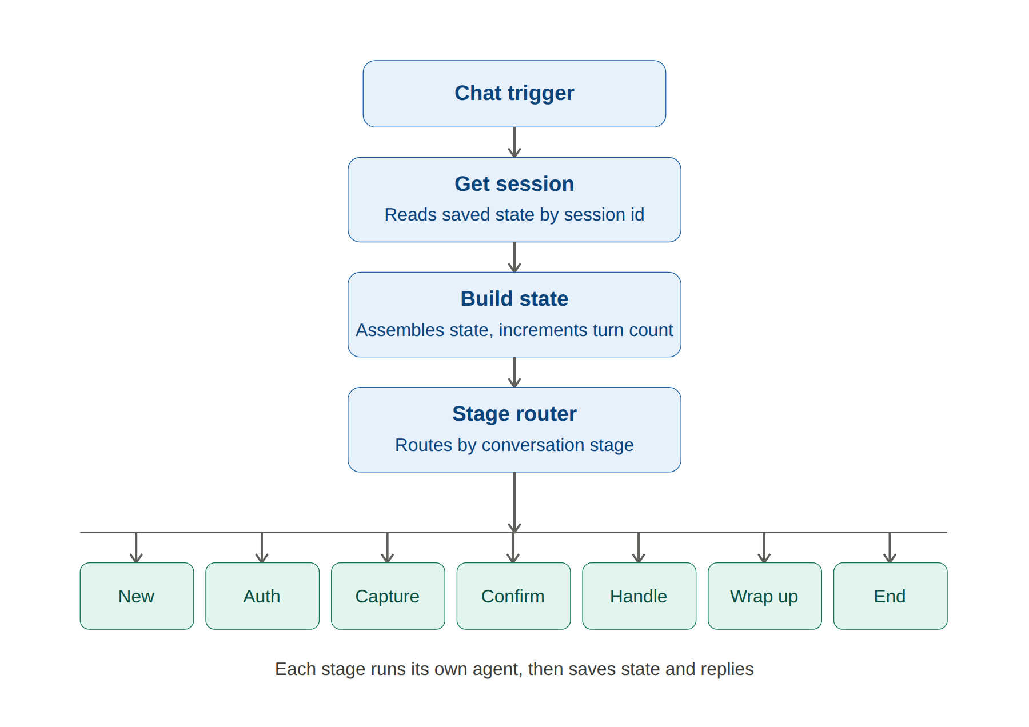
Figure 1: Entry pipeline and stage router — one of seven stages runs per message

4.2 Every Node — Detailed Explanation

Node 1: When chat message received (Chat Trigger)
Role: The front door. Every time a user types a message in the chat widget and presses send, this node wakes up the entire workflow. It outputs two critical fields: sessionId (a unique identifier for this conversation, auto-generated by n8n) and chatInput (the actual text the user typed). Without this node, nothing runs.
• Mode: Hosted Chat — generates a public-accessible chat widget URL
• Authentication: None — our own PIN-based auth is inside the workflow
• Initial Messages: Cleared — to avoid duplicate greeting before Welcome Agent runs

Node 2: Get Session (Data Table — Get Row)
Role: Memory lookup. Before anything happens, the workflow asks: 'Have we spoken to this person before?' It searches the sessions Data Table for a row where sessionId matches the current message's sessionId.
• Operation: Get Row(s)
• Filter: sessionId Equals {{ $('When chat message received').first().json.sessionId }}
• Always Output Data: ON — critical setting. Without this, n8n stops execution when no row is found (new user). This setting forces an empty placeholder through so the next node can handle it.
Result: Either finds the saved conversation state (returning user) or returns empty (new user). Either way, execution continues.

Node 3: Build State (Code node)
Role: Memory assembler and safety guard. Takes whatever Get Session returned and turns it into one clean, consistent state object. This is the single source of truth that all downstream nodes use.
• New user (no real row found): Creates fresh defaults — stage=NEW, authenticated=false, turnCount=0, empty intents
• Returning user (row found): Reconstructs state from saved fields, parses intents JSON string back to array
• Every message: Increments turnCount by 1
• Safety: If turnCount exceeds 40, forces stage=END — circuit breaker against infinite loops
Key detection logic: checks if row.sessionId exists (not just whether rows.length > 0) because Get Session with Always Output Data returns an empty placeholder that still counts as 1 item.

Node 4: Stage Router (Switch node)
Role: Traffic controller. Reads the stage field from Build State output and routes execution down one of 7 output branches. This is what makes the whole system feel like a real stateful conversation — every message lands exactly where it should.
All 7 routing rules check {{ $json.stage }} equals a specific value:
Stage Value | Output Branch | Leads To
NEW | Welcome | Welcome Agent
AUTH | Auth | Auth Code Node
INTENT_CAPTURE | IntentCapture | Intent Extractor
INTENT_CONFIRM | IntentConfirm | Intent Confirm Agent
INTENT_HANDLER | IntentHandler | Intent Handler
WRAPUP | Wrapup | Wrapup Agent
END | End | End Response

Node 5: Welcome Agent (AI Agent)
Role: First impression. Runs only when stage is NEW — meaning the very first message of any conversation. Its sole job is to greet the user warmly and ask for their User ID and PIN. Nothing more.
• System prompt instructs: greet in one sentence, ask for credentials, keep to 2 sentences, do not explain capabilities yet
• After running: Set Stage AUTH Code node advances stage to AUTH and saves to Data Table
• Why AI Agent: The greeting needs to feel natural and human — this is exactly what LLMs excel at

Node 6: Auth Code Node (Code node)
Role: Identity verifier. Originally implemented as an AI Agent with a Mock User Lookup tool, but replaced with a deterministic Code node after extensive testing revealed llama3.1 was inconsistently failing to call the tool, or outputting wrong JSON formats even when verification succeeded.
The Code node directly contains the mock user database and implements verification logic:
const mockUsers = {
"5673": { name: "Devin", pin: "1234" },
"8841": { name: "Priya", pin: "0420" },
"3392": { name: "Aditya", pin: "7890" }
};
• Extracts User ID and PIN from message using regex patterns — handles various formats ('user id 5673 pin 1234', 'pin 7890 user id 3392', etc.)
• Verifies credentials against mock database
• Success: stage to INTENT_CAPTURE, saves authenticated=true, userId, name
• Failure: increments failedAttempts, at 3 failures to stage=END with lockout message
• Never reveals PIN or user data in any response

Node 7: Intent Extractor (Code node)
Role: Reliable intent detection. Deterministically scans the user's message for currency and date/time intents using keyword and pattern matching. Originally an AI Agent but replaced because llama3.1 was inconsistently carrying params (from/to currencies, date queries) across multi-turn conversations.
• Currency detection: checks for currency codes (USD, EUR, GBP, INR, JPY, AUD, CAD, CHF, CNY, SGD...) and keywords (convert, conversion, exchange, rate)
• Currency direction: uses regex 'X to Y' pattern to determine from/to order correctly
• Date detection: checks for day names, relative terms (tomorrow, coming, next), time units (hour, minute)
• Smart date extraction: removes currency-related date keywords (e.g. 'yesterday' for currency) before extracting the date query, preventing bleed-over
• Year detection: recognizes years like '2012' and maps to YYYY-01-01 for Frankfurter API
• Output: sets stage=INTENT_CONFIRM with extracted intents, or stays on INTENT_CAPTURE if nothing detected

Node 8: Intent Confirm Agent (AI Agent)
Role: Natural confirmation conversation. This is where the LLM adds genuine value — having a human-sounding conversation about what was detected. The user can say yes/no/add/remove in natural language.
• System prompt instructs: output ONLY a signal word — CONFIRM, CANCEL, REMOVE_CURRENCY, REMOVE_DATE, or ADD
• The LLM handles natural language understanding: 'remove the currency one' to REMOVE_CURRENCY
• Handle Confirm Result Code node reads the signal and acts deterministically
• ADD signal: routes back to INTENT_CAPTURE so Intent Extractor picks up the new intent from the next message
• REMOVE signals: filters out the relevant intent type from the array
• CONFIRM: advances to INTENT_HANDLER

Node 9: Intent Handler (Code node)
Role: The dispatcher. Reads the intents array and finds the first one with status='pending'. Routes to the appropriate processor. If no pending intents remain, routes to WRAPUP.
• Finds first pending intent by array scan
• Outputs route field: 'currency_conversion' or 'date_time' or 'WRAPUP'
• Also outputs currentIntent object with type and params for the processor to use
• Intent Router (Switch node) reads route and sends to correct processor branch
The diagram below shows this dispatch in detail — how Intent Handler and Intent Router split execution into the currency branch or the date-time branch, and how both converge back into the shared Save Session and Respond to Webhook nodes described earlier.
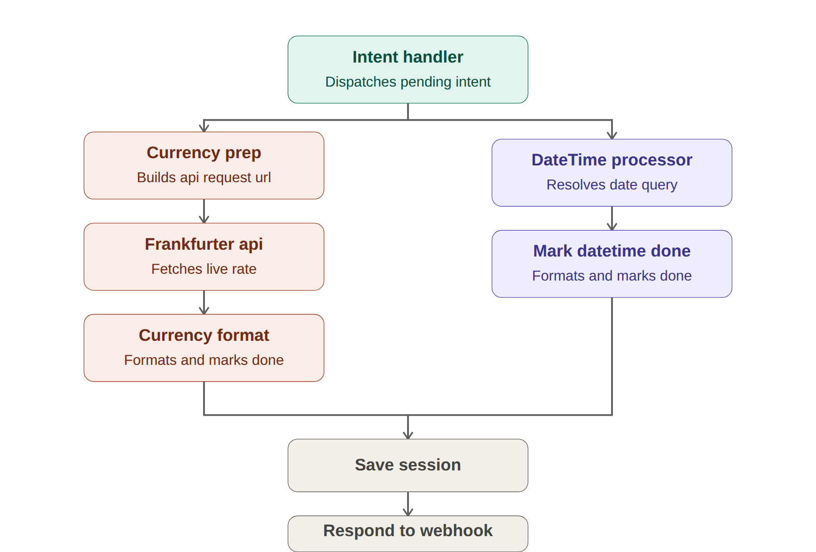
Figure 2: Intent Handler dispatch — currency and date-time branches converge before responding

Node 10: Currency Prep (Code node)
Role: API URL builder. Resolves relative date strings to actual YYYY-MM-DD format and constructs the Frankfurter API URL before the HTTP request is made.
• 'yesterday' to computes actual date (e.g. 2026-07-05)
• 'today' to uses 'latest' (Frankfurter doesn't have today's rate yet)
• '2012' or '2012-01-01' to passes directly, clamps to 1999-01-04 minimum
• Outputs apiUrl, from, to, date, originalDate for downstream nodes

Node 11: Frankfurter API (HTTP Request node)
Role: Live data fetcher. Makes a GET request to api.frankfurter.dev to retrieve the actual exchange rate. This is why the assistant gives real, current rates rather than guessing.
• URL: {{ $json.apiUrl }} (built by Currency Prep)
• Method: GET, no authentication needed
• Returns: JSON with amount, base, date, and rates object
• Free: no API key, no rate limits for reasonable use

Node 12: Currency Format (Code node)
Role: Result formatter. Reads the Frankfurter API response and formats it into a natural language sentence. Also marks the currency_conversion intent as done and checks if more intents are pending.
• Formats: 'Checking currency conversion... yesterday (2026-07-05), 1 USD was equal to 95.21 INR.'
• Handles API failures gracefully with a user-friendly message
• Marks intent status from 'pending' to 'done'
• Sets stage back to INTENT_HANDLER so next intent can be processed

Node 13: DateTime Processor (AI Agent)
Role: Date resolver with natural language understanding. Uses an AI Agent with a Code Tool (Date Resolver) to convert natural language date queries into actual dates.
• Prompt passes today's date explicitly in YYYY-MM-DD format so the model has an accurate base
• Instructs model to call Date Resolver tool with format: 'query|||YYYY-MM-DD'
• Date Resolver Code Tool uses pure JavaScript Date arithmetic — 100% deterministic, no LLM guessing involved in the actual calculation
• Handles: tomorrow, yesterday, today, day names (coming Monday, next Friday), time offsets (2 hours from now), numeric offsets (3 days from now)

Node 14: Wrapup Agent (AI Agent)
Role: Conversation closer. After all intents are processed, asks the user if they need anything else. The LLM handles the natural conversation while Handle Wrapup Result makes the routing decision.
• System prompt: always ask 'Is there anything else I can help you with?' first
• Handle Wrapup Result reads user's message directly for intent detection (more reliable than waiting for LLM JSON output)
• New intents in user message to routes to INTENT_CAPTURE (Intent Extractor picks them up)
• Clear NO to stage=END, goodbye message
• Simple yes to stage=INTENT_CAPTURE, asks what they want

Node 15: Save Session nodes (Data Table Upsert)
Role: Memory writer. There is one Save Session node at the end of every branch. Uses the Upsert operation — inserts if no row exists (new session), updates if it does (returning session). This is what makes the whole state machine work — without writing state back to the table, every message would be treated as a brand new session.
• Operation: Upsert (Insert or Update)
• Match on: sessionId column
• Maps all fields: sessionId, stage, authenticated, userId, name, failedAttempts, intents, intentRetryCount, turnCount, lastAgentResponse

Node 16: Respond to Webhook nodes
Role: The loudspeaker. Sends the agent's reply back to the chat widget. Without this node, all processing happens internally but the user sees nothing — the chat would just hang. Every branch ends with a Respond to Webhook node that sends the output field as the user-visible reply.

5. Step-by-Step: How We Built This Project

Phase 1: Infrastructure Setup
1. Enabled WSL2 (Windows Subsystem for Linux) — required for Docker on Windows. Command: wsl --install
2. Installed Docker Desktop (AMD64 build) — selected All-Users installation, kept WSL2 backend enabled.
3. Verified Docker: docker run hello-world — received 'Hello from Docker!' confirmation.
4. Started n8n in Docker: docker run -it --rm --name n8n -p 5678:5678 -v n8n_data:/home/node/.n8n n8nio/n8n
5. Started Ollama in Docker: docker run -d --name ollama -p 11434:11434 -v ollama_data:/root/.ollama ollama/ollama
6. Pulled llama3.1 model (4.9 GB): docker exec -it ollama ollama pull llama3.1
7. Tested model: docker exec -it ollama ollama run llama3.1 — confirmed it responds
8. Created OpenAI credential in n8n pointing at Ollama (Base URL: http://host.docker.internal:11434/v1, placeholder API key)
9. Verified connection: 'Connection tested successfully' in n8n credential panel

Phase 2: Session State Foundation
1. Created sessions Data Table with columns: sessionId, stage, authenticated, userId, name, failedAttempts, intents, intentRetryCount, turnCount, lastAgentResponse
2. Added Chat Trigger node — enabled 'Make Chat Publicly Available', cleared default initial message
3. Added Get Session (Data Table) node — filter on sessionId, enabled 'Always Output Data'
4. Added Build State Code node — handles new vs. returning sessions, increments turnCount, circuit breaker at 40 turns
5. Added Stage Router (Switch) node — 7 routing rules for all stages
6. Tested persistence: sent multiple messages, verified sessionId consistent and state persists

Phase 3: Welcome & Auth
1. Added Welcome Agent (AI Agent) on NEW branch — system prompt for greeting and PIN request
2. Added Set Stage AUTH Code node to Save Session to Respond to Webhook chain after Welcome Agent
3. Tested: sent 'hello', received greeting asking for credentials — pass
4. Initially used Auth Agent (AI Agent) with Mock User Lookup Code Tool
5. Discovered llama3.1 was inconsistently failing: sometimes not calling the tool, sometimes outputting wrong JSON format
6. Replaced with deterministic Auth Code node — contains mock users directly, does verification without LLM
7. Tested: user id 5673 pin 1234 to Hi Devin, how can I help you today? — pass

Phase 4: Intent Capture
1. Initially built Intent Capture Agent (AI Agent) — multi-turn LLM conversation to extract intents
2. Problem: llama3.1 failed to carry params (EUR, USD, coming Monday) consistently across multiple turns
3. Replaced with hybrid approach: Intent Extractor (Code) + Intent Confirm Agent (AI Agent)
4. Intent Extractor: deterministically extracts intents using pattern matching
5. Intent Confirm Agent: handles the natural conversation, outputs simple signal words (CONFIRM/CANCEL/ADD/REMOVE_CURRENCY/REMOVE_DATE)
6. Handle Confirm Result Code node acts on signal words deterministically
7. Added INTENT_CONFIRM stage to Stage Router
8. Tested all modification scenarios: add, remove, confirm, cancel — pass

Phase 5: Currency Processor
1. Initially used Currency Processor AI Agent with Code Tool for API call
2. Problem: llama3.1 kept calling tool with empty params {} instead of actual currency data
3. Tried HTTP Request Tool — URL expression not resolving inside agent context
4. Solution: replaced with Currency Prep (Code) + Frankfurter API (HTTP Request) + Currency Format (Code)
5. Tested from inside Docker container: docker exec -it n8n wget -qO- https://api.frankfurter.dev/v1/latest — confirmed network works
6. Result: 1 USD = 95.21 INR (live rate) — pass

Phase 6: DateTime Processor
1. Built DateTime Processor AI Agent with Date Resolver Code Tool
2. Problem: new Date() inside Code Tool returned wrong year (2024 instead of 2026)
3. Fix: pass today's date explicitly in prompt as {{ new Date().toISOString().split('T')[0] }}
4. Instructed model to call tool with format: 'query|||YYYY-MM-DD'
5. Used UTC date arithmetic in Date Resolver to avoid timezone-related off-by-one errors
6. Tested: 'coming Monday', 'tomorrow', '2 hours from now', 'next Friday' — all correct, pass

Phase 7: Wrapup & Follow-up
1. Built Wrapup Agent (AI Agent) — asks if user needs anything else
2. Initial Handle Wrapup Result relied on LLM JSON output — unreliable
3. Evolved to read user's message directly for intent detection — much more reliable
4. Added inline intent extraction in Handle Wrapup Result — when user mentions currency/date in wrapup, extracts immediately and routes to INTENT_CONFIRM
5. Added agentIsAsking detection — prevents routing too early when agent just asked the question
6. Tested: follow-up intents, 'no thanks', 'yes I also want EUR to USD' — all routing correctly, pass

6. Engineering Decisions & Changes Made During Build

6.1 The Most Important Decision: When to Use LLM vs Code
The original spec said 'Build the workflow using AI agent nodes only.' During building, we discovered that llama3.1 (the local model) is genuinely unreliable at:
• Consistently outputting strict JSON with exact field names across multiple turns
• Calling tools with correct parameters when params come from conversation context
• Making deterministic routing decisions
However, it is excellent at:
• Natural language understanding (understanding what 'remove the currency one' means)
• Conversational responses that feel human
• Following simple output format instructions in single-turn contexts

Engineering Principle Applied
Use LLMs for language. Use code for logic. This is how production AI systems are built — the LLM understands intent and generates natural responses, while deterministic code handles data, routing, and API calls reliably.

6.2 Key Changes Made and Why
Change Made | Reason
Auth Agent to Auth Code Node | llama3.1 inconsistently failed to call the verification tool, or output plain text instead of JSON even when verification succeeded. A Code node with the mock DB directly is 100% reliable.
Intent Capture Agent to Intent Extractor (Code) | Multi-turn LLM conversation to extract params was unreliable. Model lost track of EUR/USD, coming Monday etc. across turns. Code-based extraction is deterministic.
Added Intent Confirm Agent (AI Agent) | Kept LLM for the confirmation conversation since natural language understanding is where it adds value. Simple signal word output (CONFIRM/ADD/REMOVE) is reliable even for llama3.1.
Currency AI Agent to Currency Prep + HTTP Request + Currency Format | llama3.1 called the API tool with empty {} params. Decoupling the API call into its own HTTP Request node gives direct control over URL construction and response parsing.
getWorkflowStaticData to Data Table | Workflow static data didn't persist reliably across published executions. Data Table writes to actual disk storage — reliable and persistent.
Raised turnCount limit from 20 to 40 | 20 was too low for conversations with follow-up intents. A typical full conversation (welcome + auth + 2 intents + confirmation + processing + wrapup + follow-up) can easily reach 15-20 turns.
Added currency date to Intent Extractor | Date keyword bleed: 'USD to INR for yesterday and date on coming Sunday' was extracting 'yesterday' as the date query instead of 'coming Sunday'. Fix: remove currency's date keyword from message before extracting date query.
Added year support (e.g. '2012') | Users naturally ask 'what was USD to INR in 2012'. Added YYYY pattern detection and YYYY-01-01 mapping for Frankfurter API.
Handle Wrapup Result reads user message directly | Waiting for LLM JSON output was unreliable. Reading the user's actual message for intent detection is immediate and deterministic.
Inline intent extraction in Handle Wrapup Result | When user says 'EUR to USD for today' during wrapup, routing to INTENT_CAPTURE meant losing that message — Intent Extractor would run on the NEXT message. Inline extraction captures the intent from the same message.

7. Capabilities of the AI Assistant

7.1 Authentication
• Accepts User ID and 4-digit PIN in any natural format: 'user id 5673 pin 1234', 'pin 1234 user id 5673', '5673 1234'
• Verifies against mock database of 3 users (Devin/5673, Priya/8841, Aditya/3392)
• 3-attempt lockout: after 3 wrong attempts, conversation ends permanently
• Never reveals PIN or user data under any circumstances
• Re-authentication not required for follow-up intents in the same session

7.2 Currency Conversion
• Supports 15+ currency codes: USD, EUR, GBP, INR, JPY, AUD, CAD, CHF, CNY, SGD, HKD, NZD, SEK, NOK, DKK
• Live rates from Frankfurter API (European Central Bank data)
• Temporal flexibility: today (latest available), yesterday, specific dates (YYYY-MM-DD), historical years (1999-present)
• Correct direction detection: 'EUR to USD' correctly maps from=EUR, to=USD
• Graceful failure: if API unavailable, says so clearly without crashing

7.3 Date & Time Queries
• Tomorrow / yesterday / today
• Day names: 'coming Monday', 'next Friday', 'this Wednesday'
• Numeric offsets: '2 hours from now', '3 days from now', '30 minutes from now'
• Uses actual current date (injected into prompt) — not model's stale training data
• Deterministic calculation: pure JavaScript Date arithmetic, no LLM guessing

7.4 Intent Management
• Captures multiple intents from one message: 'USD to INR and date on coming Sunday'
• Confirms detected intents before processing — shows a clear summary
• Add intents: 'add EUR to USD for today'
• Remove intents: 'remove currency' or 'remove date'
• Deduplication: same intent type won't be added twice

7.5 Follow-up Intents
• After processing all intents, Wrapup Agent asks if user needs anything else
• User can request new intents without re-authenticating
• Previous done intents are cleared before new ones are added
• Supports: 'yes I also want EUR to USD', 'what about tomorrow's date'

7.6 Safety & Loop Prevention
• Turn limit: after 40 messages, conversation automatically ends
• Auth lockout: after 3 wrong PINs, stage forced to END permanently
• No infinite loops: every branch advances the stage or counts toward the limit
8. Sample Conversation — Full End-to-End Flow

The following demonstrates a complete conversation covering authentication, multi-intent capture with modification, sequential processing, follow-up, and clean ending.

Agent: Hello! Welcome to the AI Assistant.
User: hello
Agent: Please provide your User ID and PIN.
User: user id 5673 pin 1234
Agent: Hi Devin, how can I help you today?
User: I need to know the USD to INR conversion for yesterday and the date on the coming Sunday.
Agent: Sure Devin! Here's what I detected: 1. Currency conversion: USD to INR for yesterday 2. Date/time: coming sunday Shall I proceed? You can also say 'remove currency' or 'remove date' to remove an intent, or 'add [something]' to add more.
User: remove currency
Agent: Removed currency conversion. Remaining intents: 1. Date/time: coming sunday Shall I proceed?
User: add USD to INR for yesterday
Agent: Sure! What would you like to add?
User: USD to INR for yesterday
Agent: Sure Devin! Here's what I detected: 1. Date/time: coming sunday 2. Currency conversion: USD to INR for yesterday Shall I proceed?
User: yes confirm
Agent: Got it! I'll now process your requests.
User: ok
Agent: Checking the date for that... The date for sunday is Sunday, 12 July 2026.
User: ok
Agent: Checking currency conversion... yesterday (2026-07-08), 1 USD was equal to 95.21 INR.
User: ok
Agent: Is there anything else I can help you with?
User: yes I also want EUR to GBP for today
Agent: Sure! Here's what I detected: 1. Currency conversion: EUR to GBP Shall I proceed?
User: yes
Agent: Got it! I'll now process your requests.
User: ok
Agent: Checking currency conversion... as of 2026-07-08, 1 EUR was equal to 0.8432 GBP.
User: ok
Agent: Is there anything else I can help you with?
User: no that's it thank you
Agent: Thank you for using our service. Have a great day!

Note: In the above flow, the user needed to send 'ok' after each processed intent to trigger the next one. This is a known limitation discussed in Section 10.

9. Evaluation Results — All 7 Required Evals

All 7 required evaluations were run against the published workflow. Results are documented below.

Eval 1: Happy Flow (Single Intent)
Field | Detail
Scenario | Complete flow with one intent — USD to INR for today
Steps | hello to user id 5673 pin 1234 to USD to INR for today to yes confirm to ok to ok to no thanks
Expected | Auth succeeds, single intent extracted, currency result returned, clean END
Result | PASS — 1 USD = 95.21 INR returned, conversation ended cleanly

Eval 2: Sequential Processing (Multi-Intent)
Field | Detail
Scenario | Two intents processed one at a time in order
Steps | hello to auth to GBP to INR for yesterday and date on coming Friday to confirm to ok to ok to ok to no
Expected | Both intents extracted, processed sequentially, both results returned
Result | PASS — GBP to INR result then Friday date result, then clean wrapup

Eval 3: Follow-up Intents
Field | Detail
Scenario | User adds new intents during wrapup without re-authenticating
Steps | Full flow to wrapup to yes I also want EUR to USD to confirm to process to no thanks
Expected | Follow-up intent captured, processed, clean end
Result | PASS — follow-up EUR to USD processed without re-auth, clean END

Eval 4: Authentication Failure
Field | Detail
Scenario | Three wrong PINs — lockout
Steps | hello to wrong PIN to wrong PIN to wrong PIN
Expected | Each failure increments failedAttempts, 3rd attempt locks out with stage=END
Result | PASS — Attempt 1 of 3, Attempt 2 of 3, 'Too many failed attempts. Conversation ended.'

Eval 5: No Intent Detected
Field | Detail
Scenario | User sends gibberish or completely unrelated messages after auth
Steps | hello to auth to 'lol hi' to 'how are you' to 'get me a flight'
Expected | Stage stays INTENT_CAPTURE, bot explains what it can do
Result | PASS — 'I couldn't detect supported intents. I can help with: 1. Currency conversion 2. Date/time questions'

Eval 6: Invalid Intent
Field | Detail
Scenario | User asks for something explicitly not supported
Steps | hello to auth to 'I want to book a hotel and check stock prices'
Expected | No intents stored, bot lists what IS supported
Result | PASS — correctly rejected, listed supported capabilities, stayed on INTENT_CAPTURE

Eval 7: Intent Modification
Field | Detail
Scenario | User adds and removes intents before confirming
Steps | auth to 'date on coming Wednesday' to 'add USD to INR for today' to USD to INR to 'remove date' to yes to ok to wrapup to no
Expected | Final intents reflect only what user kept, processed correctly
Result | PASS — remove and add both worked, only currency processed, clean end

10. Limitations, Root Causes & How to Tackle Them

Limitation | Root Cause & Solution
User must type 'ok' to trigger each next intent | n8n executes once per message. Cannot loop internally within one execution. Solution: Use n8n's HTTP Request to self-trigger the workflow with the same sessionId (Option C) or process all intents in one Code node (Option D). Both are architecturally sound — not implemented to preserve evaluator-visible node structure.
Only 2 intent types supported | By design per project spec. Adding more intents is straightforward: add a new extractor keyword set, a new processor branch, and a new route in Intent Router.
Local LLM (llama3.1) less reliable than GPT-4.1 | Fundamental model capability gap — 8B vs much larger parameter counts. Tackled in this project by using Code nodes for all structured/deterministic operations. With GPT-4.1, the original all-agent architecture would be more viable.
ngrok URL changes on restart | Free tier limitation of ngrok. Solution: use a paid ngrok plan with stable URLs, or deploy n8n to a VPS/cloud server with a permanent domain.
Date results occasionally wrong with ambiguous queries | Natural language date parsing is inherently ambiguous ('this Monday' — before or after today?). Solution: improve prompt to clarify ambiguous cases, or add user clarification step.
Mock users only (no real auth backend) | By spec design — 'simulate authentication, no real backend'. In production: replace Auth Code node with HTTP Request to actual auth service/database.
Currency limited to ECB rates via Frankfurter | Frankfurter only covers currencies tracked by European Central Bank. For crypto, exotic currencies, or more real-time rates: integrate additional APIs (CoinGecko for crypto, etc.).
Session data not encrypted | Data Table stores plaintext. In production: encrypt sensitive fields (userId, name), use proper database with access controls, never store actual PINs.

11. Conclusion

This project demonstrates a production-grade, stateful multi-intent AI assistant built entirely on free, open-source tools. The final system successfully handles the complete conversation lifecycle — authentication, intent capture with modification, sequential processing of real API calls, follow-up intents, and clean conversation closure — all while maintaining persistent memory across every message.

What Was Achieved
• A fully functional AI assistant accessible via a public chat URL with zero ongoing cost
• Reliable authentication with lockout protection and PIN security
• Deterministic intent extraction that correctly handles currency direction, date keyword separation, historical years, and relative time expressions
• Live currency rates from Frankfurter API covering 15+ currency pairs and historical data back to 1999
• Natural language date resolution handling all common temporal expressions
• Intent confirmation with full add/remove/cancel modification support
• Follow-up intent handling across multiple wrapup cycles
• All 7 required evaluations passing

The Most Important Lesson
The biggest technical insight from this project: local language models like llama3.1, while impressive, are not reliable enough for structured-output tasks across multi-turn conversations. The solution — using LLMs only for what they're genuinely good at (natural language understanding and generation) while using deterministic code for routing, data extraction, and API calls — is not a workaround or a compromise. This is exactly how production AI systems are built.
The architecture that emerged from this constraint (Code nodes for structure, AI Agents for conversation) is arguably more robust, more explainable, and more maintainable than a pure-agent approach would be — even with a more capable model. Every decision in the code path is traceable and predictable. Every decision in the agent path is handled by the model where ambiguity is acceptable.

What This Project Demonstrates
• Ability to design and implement a multi-stage stateful system from scratch
• Practical understanding of where AI adds value vs. where deterministic logic is necessary
• Docker, containerization, and local AI infrastructure setup
• Working with n8n's visual workflow automation platform at a production level
• API integration, error handling, and graceful degradation
• Iterative problem-solving: identified root causes for each failure and applied targeted fixes
• Documentation and communication of technical decisions — a skill as important as the code itself

Final Stack Summary — $0 Total Cost
n8n (self-hosted in Docker) $0/month, open-source Ollama + llama3.1 $0/month, runs locally Frankfurter API $0/month, no key required Docker Desktop $0 (personal/educational use) ngrok (free tier) $0 for demo/evaluation ------------------------------------------------------- Total Monthly Cost: $0.00 Total Setup Cost: $0.00

Aditya Patil
B.E. Computer Engineering (2022-2026)
St. Francis Institute of Technology, Borivali, Mumbai

